CHAPTER - 1

**Bright Idea Consulting for Services**

Introduction:

In its simplest form, consulting is the business or act of coming up with a solutions to real world business situations or problems. Often such solutions take the form of advice offered by specialists in their respective fields (to which the problems or situations belong). A consulting firm is a business comprised of industry-specific experts who offer professional advice, guidance, and actionable solutions to businesses experiencing issues they can't deal with in-house. Every company is bound to have problems; consulting firms are contracted to solve them. Sets the context for the report, outlines the objectives, and describes the scope of the consulting project.

The demand for these services is not limited to large organizations. For independent consultants, in fact, the greatest area of opportunity might be with small companies. According to the Small Business Administration, the vast majority of U.S. businesses have fewer than 100 employees.1 That represents significant opportunity for independent consultants.

As more organizations have chosen to lighten the staffing burdens by contracting for services, outsourcing opportunities have grown for independent consultants.

PURPOSES:

* Consulting firms provide feedback and actionable strategies to companies to improve their efficiency or solve complex problems in a specific area, such as advertising and technology.
* Company executives are often the ones who hire consultants to give them advice specific to their industry and organizational needs.
* Consulting firms often provide advice on major matters such as mergers and acquistions.
* They also offte guidance on more specific aspects of business, such as pricing or branding.
* Consulting firms can help to improve company marketing strategy or they can assist with thej design of a new product line.
* Because of their objectivity, consultants can also pinpoint new or unforeseen issues.
* Consulting is a process used to assess risk, achieve consunsus, or conduct arbitration.
* External management consulting experts advise company owners in order to improve their understanding of their role and mission and in order to increase the ability of successful and relevant managementd process implementation.

CHAPTER – 2

PROBLEM:

EMPATHY MAP

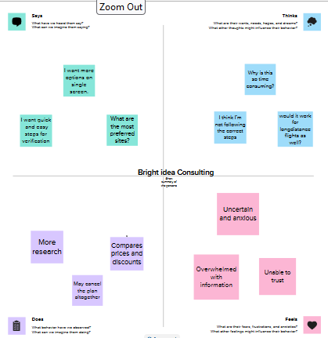

BRAINSTORMING MAP

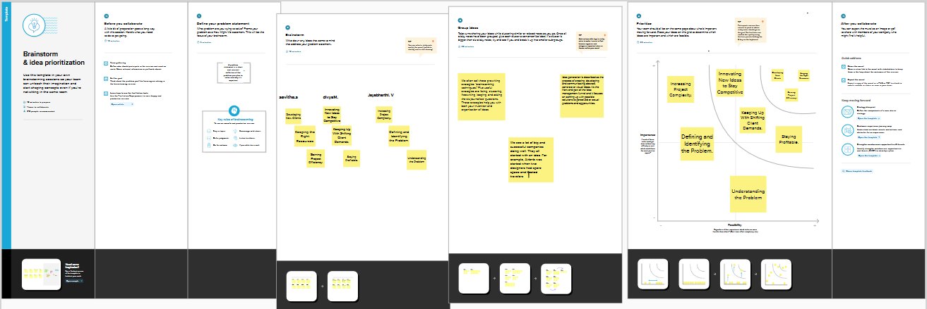

CHAPTER - 3

RESULT

PROFIT AND LOSS ACCOUNT 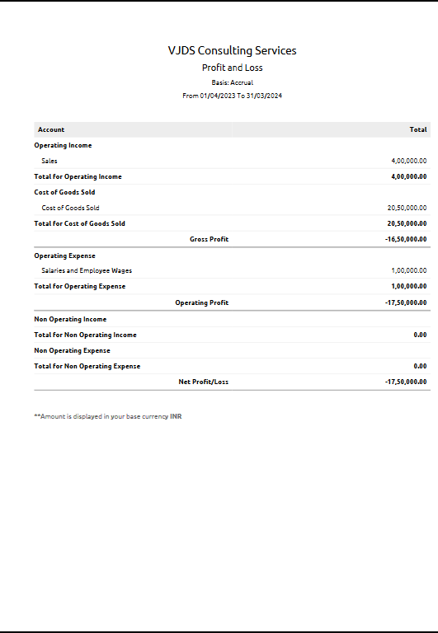

BALANCE SHEET



Chapter-4

Advantages of Bright Idea Consulting Services:

* A business consultant is very often more expensive as compared to an employee.
* Consulting services can help you identify and solve problems more efficiently.
* A competitive advantage is a point of difference between a firm and its competitors that is valued by potential clients.
* Having a lower cost structure or greater specialized expertise.
* Strategic advantage is comprised of individual strads of advantage or disadvantage relating to all available levers of power.
* Quality is the product quality should be standared or higher for the product to achieve a competitive advantage.
* Consulting is an approach driven by strategy and outcomes unlike the conventional predetermined models.
* Comparative is the process by which companies discover ways to lower the cost of their products or services to gain competitive leverage against other businesses with similar offerings.
* A company comparative advantage typically allows consumers to purchase goods or services at a lower opportunity cost.
* Access to firms and internal corporate date.
* Reputation of consultants vs academics and too abstra

Huge data base of benchmarks, industries, and global reach.

Disadvantages of Bright Idea Consulting Service:

* Difficulties with objectivity – unable to extricate themselves from the organisational culture and politics.
* May have their own preconceptions.
* Credibility undermined due to previous organisational position (too junior) and constrained by position in company hierarchy.
* May choose to avoid difficult issues.
* Prohibitive costs: Though it is usually economical to hire the services of external agency, it is not always the case. ...
* Poor quality: ...
* Problem of secrecy: ...
* Problem of discontinuation:
* Reduce time to hire. ...
* Shorten onboarding times. ...
* Cost less. ...
* Strengthen employee engagement. ...
* Create resentment among employees and managers. ...
* Leave a gap in your existing workforce. ...
* Limit your pool of applicants.

Chapter-5

Application for Bright Idea Consulting Service

Solution consulting providers offer consulting services related to technology and performance within an organization. Businesses can enlist the help of these providers to assess the IT health of their operation, determine areas for improvement, and transition or upgrade to new equipment, software, or processes. Solution consulting includes specializations such as [BI consulting](https://www.g2.com/categories/business-intelligence-bi-consulting), [digital transformation consulting](https://www.g2.com/categories/digital-transformation-consulting), and [cloud consulting](https://www.g2.com/categories/cloud-consulting). In addition to solution consulting, operations teams can benefit their organizations by seeking out [cybersecurity consulting](https://www.g2.com/categories/cybersecurity-consulting) and [marketing strategy](https://www.g2.com/categories/marketing-strategy) consulting, along with [implementation consulting](https://www.g2.com/categories/implementation-services) to help set up and transition to new software.

Chapter-6

Conclustion:

A conclusion is the final piece of writing in a research paper, essay, or article that summarizes the entire work. The conclusion paragraph should restate your thesis, summarize the key supporting ideas you discussed throughout the work, and offer your final impression on the central idea.

Highlight the key argument presented in the essay. Summarise the answer to the essay question, as signalled in the introduction. Refer back to the essay question to show that it has been answered. Reinforce the main theme of the essay, which has been established in the introduction.

The last part of something, its end or result. When you write a paper, you always end by summing up your arguments and drawing a conclusion about what you've been writing about.

Chapter-7

Future Scope

Consultancies can not only develop new revenue streams, but also better understand clients and how to create much greater value for them. To become co-creators, consultancies themselves need to develop new skills and partnerships in areas such as design, manufacturing, and marketing.

The Future of Consulting. The future of consulting will require less time on-site with clients as technology facilitates digital communication and collaboration. However, consulting will remain a team approach, and the output has to be action-oriented and bring direct added value to the client.

The global management consulting services market was valued at $316.5 billion in 2021, and is projected to reach $811.3 billion by 2031, growing at a CAGR of 10.2% according to Allied Market Research. The consulting industry in India is growing at a fast pace and soaring towards new horizons.